Link to Repository: https://github.com/SYnthestic/INF1103lab2

Docker Mount Success | 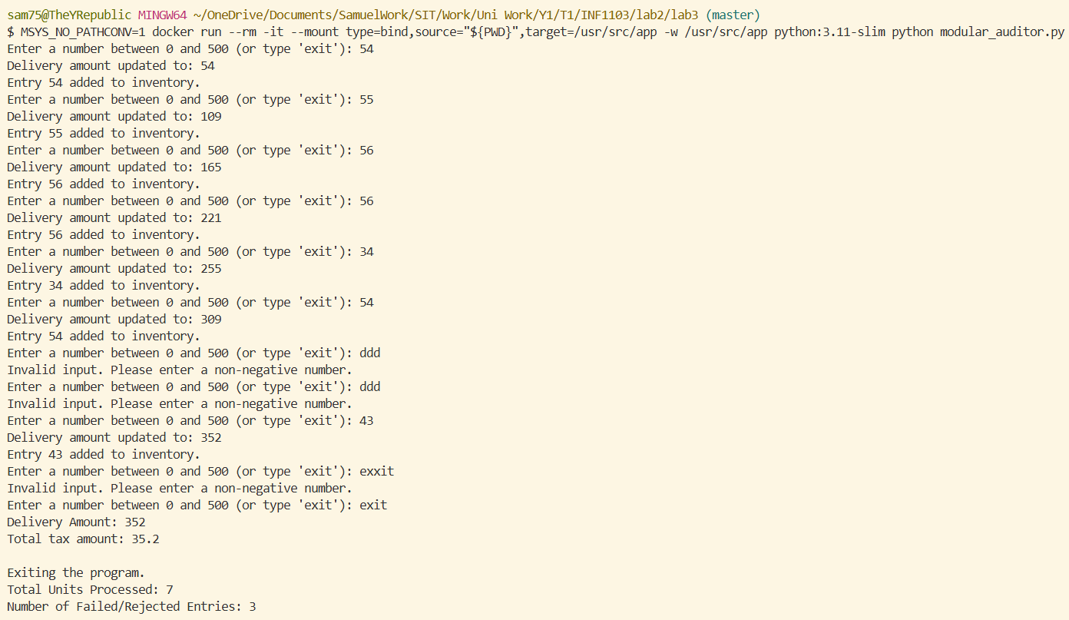
Docker Build Image | 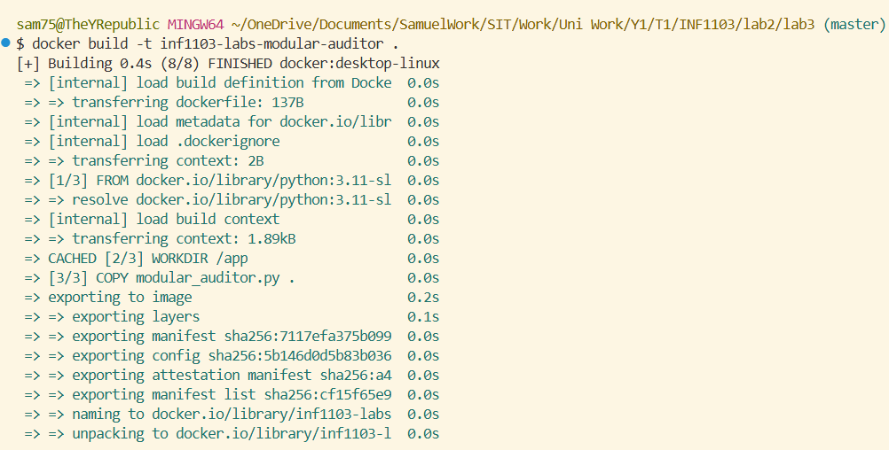
Docker Image Success | 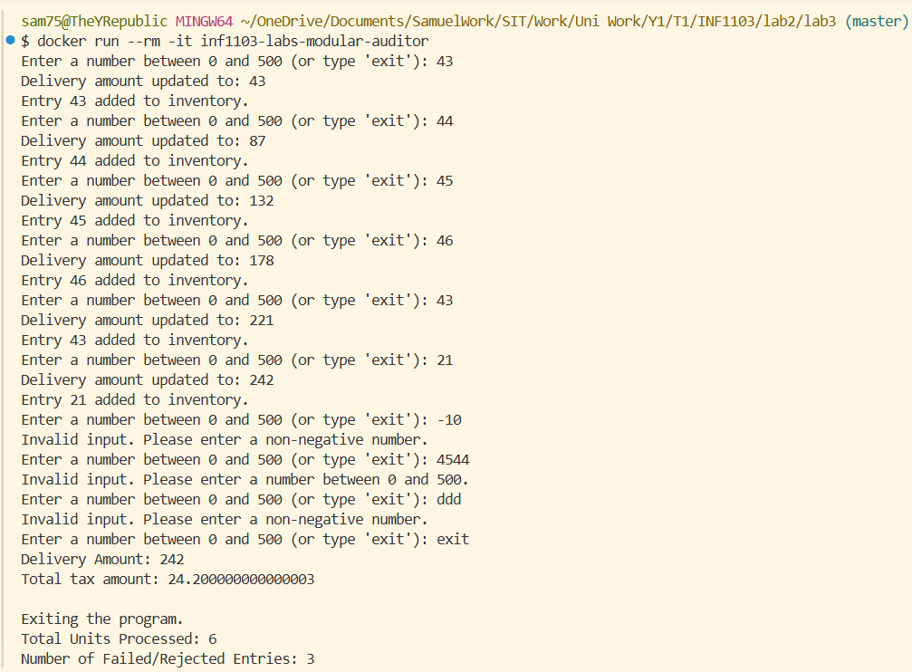
Docker Images | 